LEMBAR JAWABAN UTS SEM GENAP T.A. 2025 – 2026 MATA KULIAH PRAKTIK SISTEM KENDALI 2

NAMA : Muhammad Raffi Ramadan
NIM : 2411010009

- Soal / Studi Kasus
(Gambarkan model sistem dan tuliskan parameter)
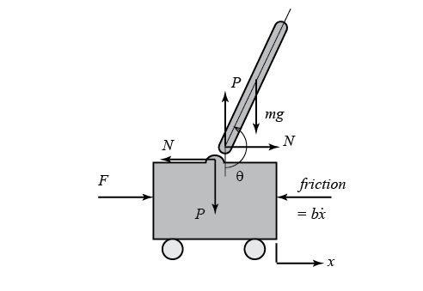
Parameter inverted pendulum.
Parameter:
(M) mass of the cart = 1 kg;
(m) mass of the pendulum = 0.6 kg;
(b) coefficient of friction for cart = 0.1 N/m/sec;
(l) length to pendulum center of mass = 0.4 m;
(I) mass moment of inertia of the pendulum = 0.008 kg.m2

Keterangan variabel
• F = gaya yang diberikan pada cart (N)
• x = posisi cart (m)
• θ = sudut pendulum terhadap posisi vertikal (rad)

Kereteria desain.
Open-Loop Impulse Response
• Input: Impulse 1 N·s
• Settling Time (θ): < 5 s
• Pendulum Angle: θ ≤ 0.05 rad

Open-Loop Step Response
• Input: Step 0.2 m
• Settling Time (x): < 5 s
• Settling Time (θ): < 5 s
• Rise Time (x): < 0.5 s
• Pendulum Angle: θ ≤ 0.35 rad (20°)
• Steady-State Error (x dan θ): < 2%

- OPEN-LOOP IMPULSE RESPONSE
%% Parameter Sistem
M = 1;
m = 0.6;
b = 0.1;
I = 0.008;
g = 9.8;
l = 0.4;

%% Konstanta
q = (M+m)*(I+m*l^2)-(m*l)^2;

%% Variabel Laplace
s = tf('s');

%% Penyebut Fungsi Transfer
den4 = s^4 + (b*(I+m*l^2)/q)*s^3 ...
- ((M+m)*m*g*l/q)*s^2 ...
- (b*m*g*l/q)*s;

den3 = s^3 + (b*(I+m*l^2)/q)*s^2 ...
- ((M+m)*m*g*l/q)*s ...
- (b*m*g*l/q);

%% Fungsi Transfer
P_cart = (((I+m*l^2)/q)*s^2 - (m*g*l/q))/den4;

P_pend = ((m*l/q)*s)/den3;

%% Sistem MIMO
sys_tf = [P_cart;
P_pend];

sys_tf.InputName = {'u'};
sys_tf.OutputName = {'x';'phi'};

%% Open-loop Impulse Response
figure;
impulse(sys_tf,10);
grid on;
title('Open-Loop Impulse Response');

%% Pole dan Zero
disp('Pole P_cart');
pole(P_cart)

disp('Zero P_cart');
zero(P_cart)

disp('Pole P_pend');
pole(P_pend)

disp('Zero P_pend');
zero(P_pend)

JAWABAN NYA :
Pole Pendulum
ans =
5.8648
-5.8979
-0.0625
Zero Pendulum
ans =
0

Pole Cart
ans =
0
5.8648
-5.8979
-0.0625
Zero Cart
ans =
4.7556
-4.7556

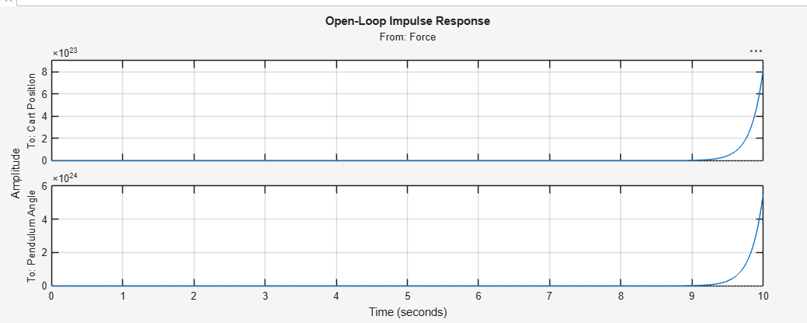

- OPEN-LOOP STEP RESPONSE

>> %% Parameter Sistem
M = 1;
m = 0.6;
b = 0.1;
I = 0.008;
g = 9.8;
l = 0.4;

%% Konstanta
q = (M+m)*(I+m*l^2)-(m*l)^2;

%% Variabel Laplace
s = tf('s');

t = 0:0.05:10;
u = ones(size(t));
[y,t] = lsim(sys_tf,u,t);
plot(t,y)
title('Open-Loop Step Response')
axis([0 3 0 50])
legend('x','phi')
step_info = lsiminfo(y,t);
cart_info = step_info(1)
pend_info = step_info(2)

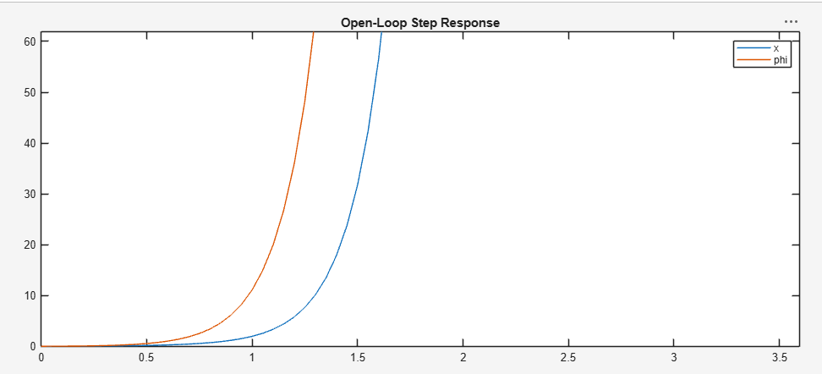

- MATLAB Code
(Copy-paste code program MATLAB dan link program di Github)
Program MATLAB:
- Fungsi transfer:

M = 0.5;
m = 0.2;
b = 0.1;
I = 0.006;
g = 9.8;
l = 0.3;
q = (M+m)*(I+m*l^2)-(m*l)^2;
s = tf('s');

P_cart = (((I+m*l^2)/q)*s^2 - (m*g*l/q))/(s^4 + (b*(I + m*l^2))*s^3/q - ((M + m)*m*g*l)*s^2/q - b*m*g*l*s/q);

P_pend = (m*l*s/q)/(s^3 + (b*(I + m*l^2))*s^2/q - ((M + m)*m*g*l)*s/q - b*m*g*l/q);

sys_tf = [P_cart ; P_pend];

inputs = {'u'};
outputs = {'x'; 'phi'};

set(sys_tf,'InputName',inputs)
set(sys_tf,'OutputName',outputs)

sys_tf

sys_tf =
From input "u" to output...
0.001231 s^2 - 0.02784
x: -------------------------------------------------------
0.001288 s^4 + 0.0001231 s^3 - 0.04455 s^2 - 0.002784 s
0.002841 s
phi: ---------------------------------------------------
0.001288 s^3 + 0.0001231 s^2 - 0.04455 s - 0.002784
Continuous-time transfer function.
Model Properties
>>
Program MATLAB:
- State-Space:

>> M = 1;
m = 0.6;
b = 0.1;
I = 0.008;
g = 9.8;
l = 0.4;

p = I*(M+m)+M*m*l^2; %denominator for the A and B matrices

A = [0 1 0 0;
0 -(I+m*l^2)*b/p (m^2*g*l^2)/p 0;
0 0 0 1;
0 -(m*l*b)/p m*g*l*(M+m)/p 0];
B = [ 0;
(I+m*l^2)/p;
0;
m*l/p];
C = [1 0 0 0;
0 0 1 0];
D = [0;
0];

states = {'x' 'x_dot' 'phi' 'phi_dot'};
inputs = {'u'};
outputs = {'x'; 'phi'};

sys_ss = ss(A,B,C,D,'statename',states,'inputname',inputs,'outputname',outputs)

sys_ss =
A =
x x_dot phi phi_dot
x 0 1 0 0
x_dot 0 -0.09559 5.188 0
phi 0 0 0 1
phi_dot 0 -0.2206 34.59 0
B =
u
x 0
x_dot 0.9559
phi 0
phi_dot 2.206
C =
x x_dot phi phi_dot
x 1 0 0 0
phi 0 0 1 0
D =
u
x 0
phi 0
Continuous-time state-space model.
Model Properties
Program MATLAB:
- Konversi State-Space ke fungsi transfer:

%% Parameter Sistem
M = 1;
m = 0.6;
b = 0.1;
I = 0.008;
g = 9.8;
l = 0.4;

%% Matriks State Space

p = I*(M+m) + M*m*l^2;

A = [0 1 0 0;
0 -(I+m*l^2)*b/p (m^2*g*l^2)/p 0;
0 0 0 1;
0 -(m*l*b)/p m*g*l*(M+m)/p 0];

B = [0;
(I+m*l^2)/p;
0;
m*l/p];

C = [1 0 0 0;
0 0 1 0];

D = [0;
0];

%% Membentuk model State Space

sys_ss = ss(A,B,C,D);

disp('=== MODEL STATE SPACE ===')
sys_ss

%% Konversi ke Fungsi Transfer

sys_tf = tf(sys_ss);

disp('=== FUNGSI TRANSFER ===')
sys_tf

%% Memisahkan Fungsi Transfer

P_cart = sys_tf(1)

P_pend = sys_tf(2)

%% Pole dan Zero

disp('Pole Cart')
pole(P_cart)

disp('Zero Cart')
zero(P_cart)

disp('Pole Pendulum')
pole(P_pend)

disp('Zero Pendulum')
zero(P_pend)

%% Impulse Response

figure
impulse(sys_tf)
grid on
title('Open Loop Impulse Response'

JAWABAN :

=== MODEL STATE SPACE ===

sys_ss =

A =
x1 x2 x3 x4
x1 0 1 0 0
x2 0 -0.09559 5.188 0
x3 0 0 0 1
x4 0 -0.2206 34.59 0

B =
u1
x1 0
x2 0.9559
x3 0
x4 2.206

C =
x1 x2 x3 x4
y1 1 0 0 0
y2 0 0 1 0

D =
u1
y1 0
y2 0

Continuous-time state-space model.
Model Properties
=== FUNGSI TRANSFER ===

sys_tf =

From input to output...
0.9559 s^2 + 1.698e-15 s - 21.62
1: ---------------------------------------
s^4 + 0.09559 s^3 - 34.59 s^2 - 2.162 s

2.206 s + 9.614e-17
2: -----------------------------------
s^3 + 0.09559 s^2 - 34.59 s - 2.162

Continuous-time transfer function.
Model Properties

P_cart =

0.9559 s^2 + 1.698e-15 s - 21.62
---------------------------------------
s^4 + 0.09559 s^3 - 34.59 s^2 - 2.162 s

Continuous-time transfer function.
Model Properties

P_pend =

2.206 s + 9.614e-17
-----------------------------------
s^3 + 0.09559 s^2 - 34.59 s - 2.162

Continuous-time transfer function.
Model Properties
Pole Cart

ans =

0
5.8648
-5.8979
-0.0625

Zero Cart

ans =

-4.7556
4.7556

Pole Pendulum

ans =

5.8648
-5.8979
-0.0625

Zero Pendulum

ans =

-4.3581e-17

Link Github: https://github.com/Rafi12404/inverted-pendulum/tree/main

- Grafik MATLAB
(Gambar grafik yang dihasilkan)
- OPEN-LOOP IMPULSE RESPONSE


- NILAI DAN GRAFIK POLES-ZERO MAP

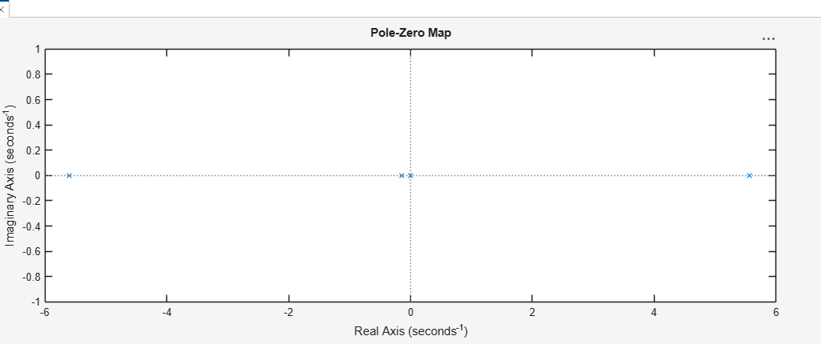
zeros =
0
poles =
5.5651
-5.6041
-0.1428
zeros =
4.9497
-4.9497
poles =
0
5.5651
-5.6041
-0.1428
- OPEN-LOOP STEP RESPONSE


>> %% Parameter Sistem
M = 1;
m = 0.6;
b = 0.1;
I = 0.008;
g = 9.8;
l = 0.4;

%% Konstanta
q = (M+m)*(I+m*l^2)-(m*l)^2;

%% Variabel Laplace
s = tf('s');

t = 0:0.05:10;
u = ones(size(t));
[y,t] = lsim(sys_tf,u,t);
plot(t,y)
title('Open-Loop Step Response')
axis([0 3 0 50])
legend('x','phi')
step_info = lsiminfo(y,t);
cart_info = step_info(1)
pend_info = step_info(2)
cart_info =
struct with fields:
TransientTime: 9.9961
SettlingTime: 9.9961
Peak: 1.3878e+23
PeakTime: 10
Min: 0
MinTime: 0
Max: 1.3878e+23
MaxTime: 10
pend_info =
struct with fields:
TransientTime: 9.9961
SettlingTime: 9.9961
Peak: 9.3507e+23
PeakTime: 10
Min: 0
MinTime: 0
Max: 9.3507e+23
MaxTime: 10

- Analisis Grafik
(Berikan penjelasan atau analisis dari grafik yang dihasilkan)
- Open-Loop Impulse Response
Pada grafik impuls, terlihat bahwa sistem merespons dengan kenaikan yang sangat tajam mendekati akhir waktu simulasi. Hal ini menunjukkan bahwa sistem tidak stabil dalam kondisi open-loop, karena sudut pendulum (θ) dan posisi cart (x) tidak kembali ke keadaan setimbang.
- Settling time (θ) tidak tercapai dalam batas < 5 s, karena sudut pendulum terus meningkat tanpa stabilisasi.
- Dengan kata lain, sistem gagal memenuhi kriteria desain untuk respon impuls.

- Open-Loop Step Response
Pada grafik step response, baik posisi cart (x) maupun sudut pendulum (θ) meningkat dengan cepat.
- Rise time (x) memang relatif cepat (< 0.5 s), sesuai kriteria.
- Namun, settling time (x dan θ) tidak tercapai dalam < 5 s, karena sistem tidak pernah benar-benar stabil.
- Sudut pendulum (θ) jauh melebihi batas 0.35 rad (20°), sehingga sistem tidak memenuhi syarat kestabilan.
- Steady-state error juga besar, karena output tidak berhenti pada nilai akhir yang diinginkan.
- Pole-Zero Plot
Dari grafik pole-zero, terlihat bahwa terdapat pole pada sumbu real yang berada di sisi kanan (positif). Hal ini menandakan sistem open-loop tidak stabil, karena adanya pole dengan bagian real positif menyebabkan respon sistem tumbuh tak terbatas.

Kesimpulan keseluruhan
- Sistem inverted pendulum dengan parameter yang diberikan tidak stabil dalam kondisi open-loop, baik pada respon impuls maupun step.
- Kriteria desain seperti settling time < 5 s, sudut pendulum ≤ 0.35 rad, dan steady-state error < 2% tidak terpenuhi.
- Pole-zero plot mengonfirmasi ketidakstabilan karena adanya pole di sebelah kanan sumbu real.
- Oleh karena itu, sistem ini memerlukan kontroler tambahan (misalnya PID, LQR, atau state feedback) agar bisa memenuhi spesifikasi desain dan menjaga pendulum tetap tegak.

